**Build an Authentication/Login System on AWS with React.js and a Serverless API**

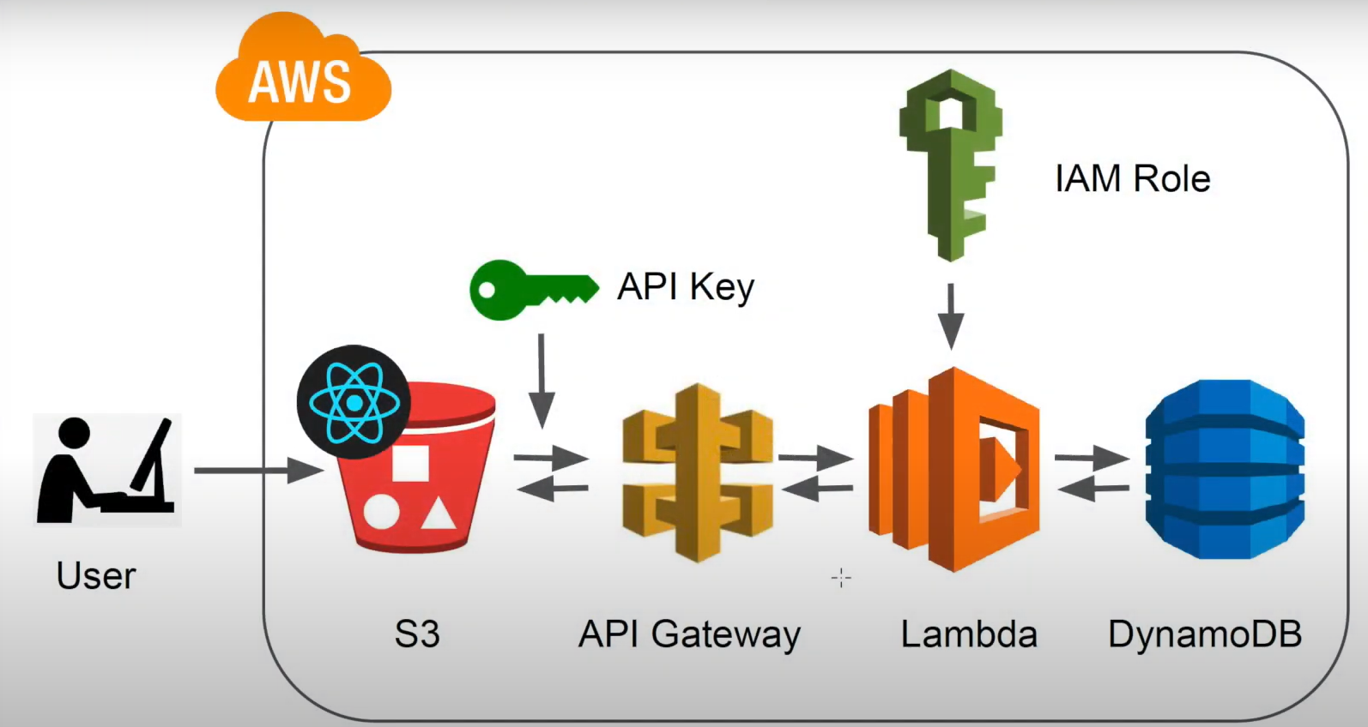

Step 1

* **Create a DynamoDB table**

2> We need to attach the IAM role to the lambda function

3> **lam policies** are

* Could watch log
* Dynamo DB

4> Create **lambda function** for API

For permission add the role that we have created

* Configuration edit the general configuration

Increase to 5 seconds

Memory to 500 mb

* Api gateway that acts front door

**5> Create resources** (endpoints)

* **health**: for health checks
* Enable "Configure as a proxy resource"
* Create a GET method, choose Lambda Function, and select the Lambda function created earlier
* **register**: endpoint to register new accounts
* Enable "Configure as proxy resource"
* Create a POST method, choose Lambda Function, and select the Lambda function
* **login:** endpoint that handles logins
* Enable "Configure as proxy resource"
* Create a POST method, choose Lambda Function, and select the Lambda function
* **verified**: endpoint to check if the access token is still valid
* Enable "Configure as proxy resource" .
* Create a POST method, choose Lambda Function, and select the Lambda function

6.

**Deploy the API**

Go back to root and deploy the API to a new stage

**7>Configure API Gateway to require an API key**